**WEEK – 12**

**1#** Write an interactive program in C to create a file & store some information (name class roll no) into it.

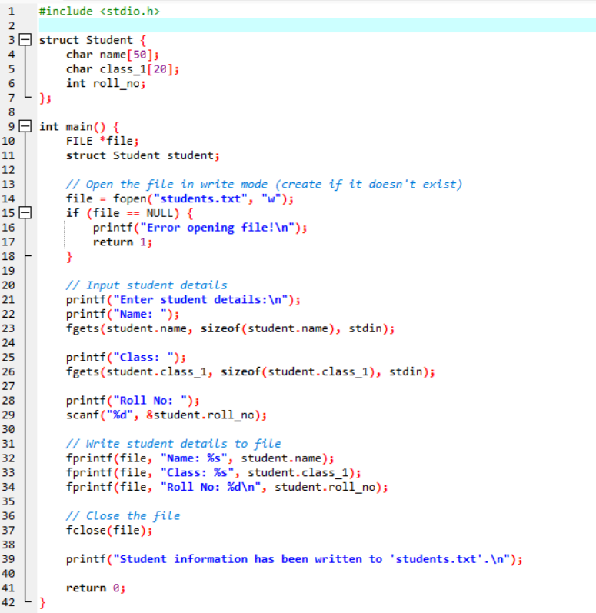

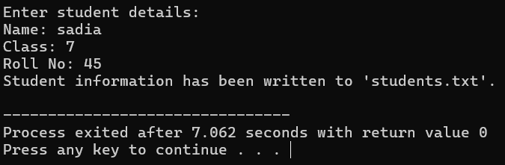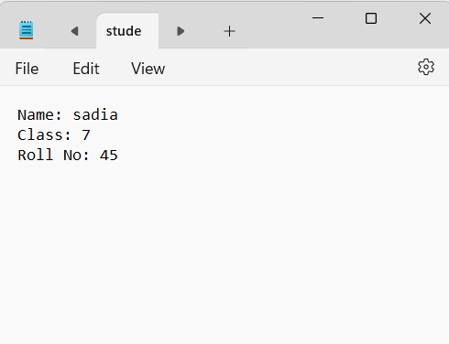

**2#** Write an interactive program in C to read the data from the file.

* Program assumes students.txt exists and contains data in the following format:

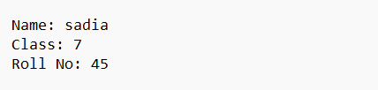

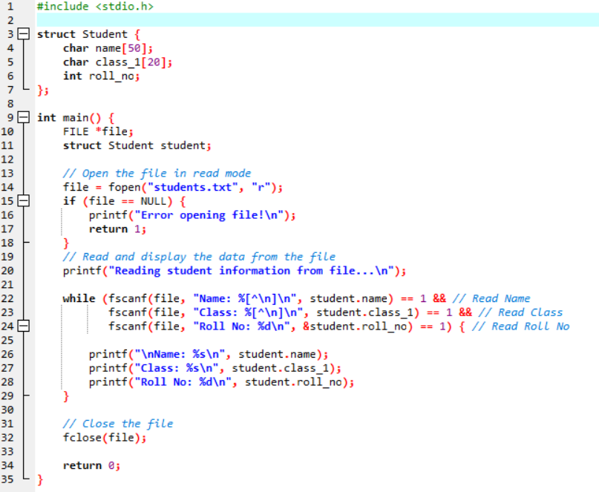

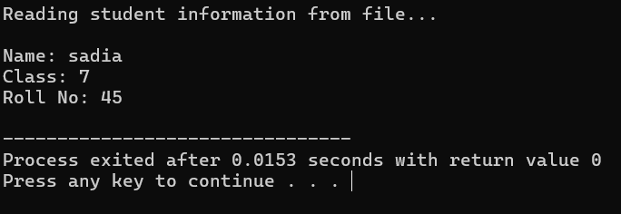

**3#** Write an interactive program in C to count the no. of lines, characters, blank spaces from the text file.

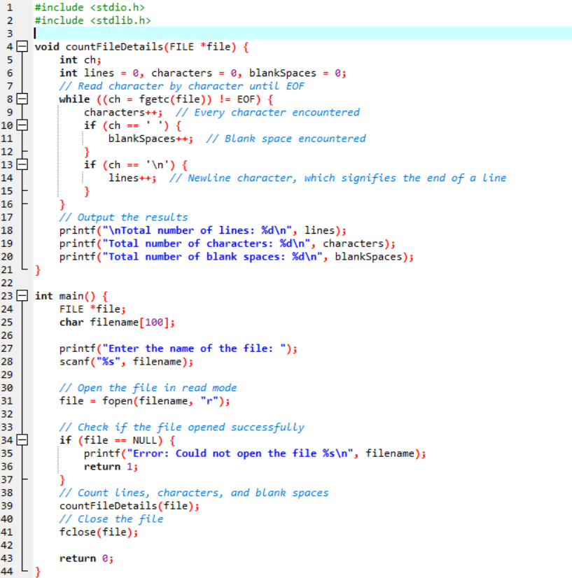

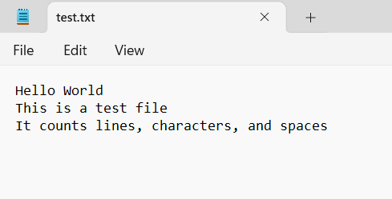

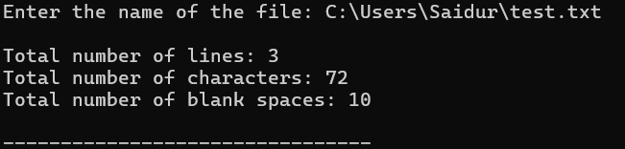

**4#** Write an interactive program in C to convert the all the content of a text file to uppercase.

